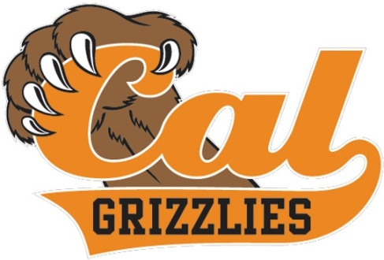

2024 Mens JV Golf Team
Principal: Demetrius Ball Athletic Director: Chad Ross

School Colors: Orange & Black Coach: Mike Pottinger
Mascot: Fightin’ Grizzlies Coach: Brian Barr
Day/Date | Opponent | Site | Time | Dismissal  Time
Go Grizzly Golf
Wed., February 28 | San Ramon JV* | Crow Canyon | 3:15 | 2:20
Wed., March 6 | Grizzly JV Tourney | Bridges | 7:30 | All Day
Tues., March 12 | DLS JV* | Bridges | 3:30 | 2:30
Thurs., March 14 | Amador Valley JV* | Bridges | 3:30 | 2:40
Wed., March 20 | Dublin JV* | Dublin Ranch | 3:30 | 2:15
Thurs., March 21 | Granada JV* | Poppy Ridge | 3:15 | 2:00
Mon., March 25 | Spring Golf Classic | Monarch Bay | 1:00 | TBA
April 1-5 | Spring Break
Tues., April 9 | Livermore JV* | Bridges | 3:30 | 2:40
Mon., April 15 | Campolindo JV | Bridges | 3:30 | 2:40
Tues., April 16 | San Ramon Valley JV* | Bridges | 3:30 | 2:40
Thurs., April 18 | Dougherty Valley/MVHS * | Bridges | 3:30 | 2:40
Tue., April 23 | Foothill JV* | Bridges | 3:30 | 2:40
Wed., April 24 | Dougherty Valley/MVHS* | Blackhawk | 3:30 | 2:00
Thurs., April 25 | DLS JV* | Oakhurst | 3:30 | 2:00
*Signifies EBAL league competition
“A National Blue Ribbon School”
Revised: 12/25/24

