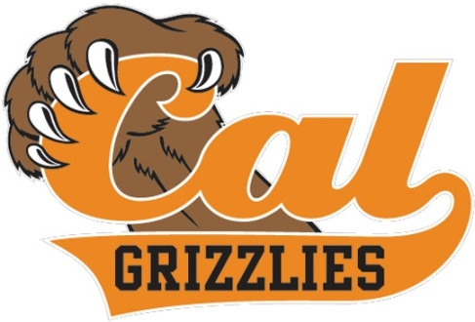

2024 Mens varsity Golf Team
Principal: Demetrius Ball Athletic Director: Chad Ross

School Colors: Orange & Black Coach: Mike Pottinger
Mascot: Fightin’ Grizzlies Coach: Brian Barr
Day/Date | Opponent | Site | Time | Dismissal  Time
Go Grizzly Golf
Mon., February 26 | Bishop O’Dowd | Bridges | 3:15 | 2:10
Wed., February 28 | Cowboy Classic | Wente | 7:30 | All Day
Thurs., February 29 | San Ramon* | Bridges | 3:15 | 2:30
Wed., March 6 | Grizzly JV Tourney | Bridges | 7:30 | All Day
Thurs., March 7 | Dougherty Valley/MVHS* | Bridges | 3:30 | 2:30
Mon., March 11 | Miramonte | Orinda | 3:00 | 2:00
Tues., March 12 | DLS* | Diablo | 3:30 | 2:20
Thurs., March 14 | Amador Valley* | Ruby Hills | 3:30 | 2:10
Mon., March 18 | Aiello Discovery Bay | Discovery Bay CC | 10:00 | All Day
Tues., March 19 | Dublin* | Bridges | 3:30 | 2:30
Thurs., March 21 | Granada* | Bridges | 3:15 | 2:15
Mon., March 25 | Spring Golf Classic | Monarch Bay | 1:00 | All Day
Wed., March 27 | Livermore* | Wente | 3:30 | 2:00
April 1-5 | Spring Break
Mon., April 8 | Miramonte | Home | 3:30 | 2:40
Thurs., April 11 | Monte Vista/DVHS* | Blackhawk | 3:30 | 2:00
Tues., April 16 | San Ramon Valley* | Crow Canyon | 3:30 | 2:30
Mon., April 22 | Transbay Tourney | Rossmore CC | 12:00 | All Day
Tues., April 23 | Foothill* | Castlewood | 3:30 | 2:10
Thurs., April 25 | DLS* | Bridges | 3:30 | 2:30
Mon., May | EBAL Championship* | TBA | TBA | All Day
*Signifies EBAL league competition
“A National Blue Ribbon School”
Revised: 1/25/24

